**MODEL**

* A model is a mathematical representation or a framework that learns patterns and relationships from the data.
* It takes the input data, processes it through various algorithms, and produces output predictions.
* These are used for the wide range of tasks such as making predictions, recognizing patterns, clustering new data.

**LANGUAGE MODELING**

* A Language model is a type of machine learning model trained to conduct a probability distribution over words. In simple, a model tries to predict the next most appropriate word to fill in a blank space in a sentence or phrase, based on the context of the given text.
* Language models are a fundamental component of natural language processing (NLP) because they allow machines to understand, generate, and analyse human language.
* Its like solving a puzzle where each piece is a word, and you are trying to find the next piece that fits.

1.Here are some of the examples for the existing language models:

* GPT2 (Generative Pre-Trained Techniques -2),
* GPT3(Generative Pre-Trained Techniques-3),
* BERT (Bidirectional Encoder Representations from Transformers),
* ELECTRA, etc.

**LARGE LANGUAGE MODEL (LLM)**

A Large Language Model is a type of artificial intelligence algorithm that uses deep learning techniques, massive datasets.

LLM s have become very popular because they have more applicability for a range of NLP tasks which includes Text generation, Sentiment analysis, Translation, Conversational AI and chatbots.

Transformers are type of neural network architecture that have been gaining popularity. Transformers were recently used by open AI in their language models.

These were developed to solve the problem of sequence transduction, or neural machine translation. That means any task that transforms the input sequence to an output sequence. This includes speech recognition, text to speech transformation, etc.

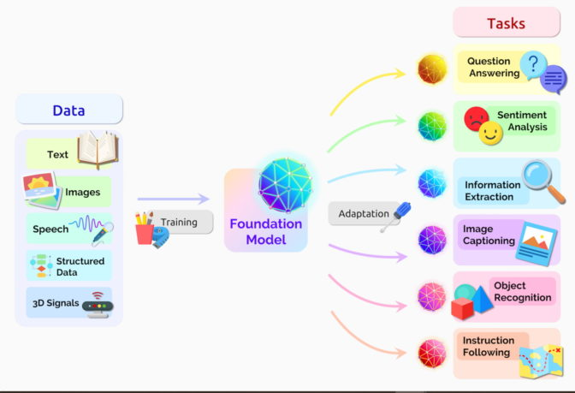

**Core concepts that are involved in building a language model:**

This section covers three fundamental aspects like Natural Learning Processing, Machine Learning and the application of Deep Learning.

**Defining Natural Language Processing:** Natural Language Processing (NLP)aims to enable computers to understand, interpret, analyse and generate the human language in a meaningful way.

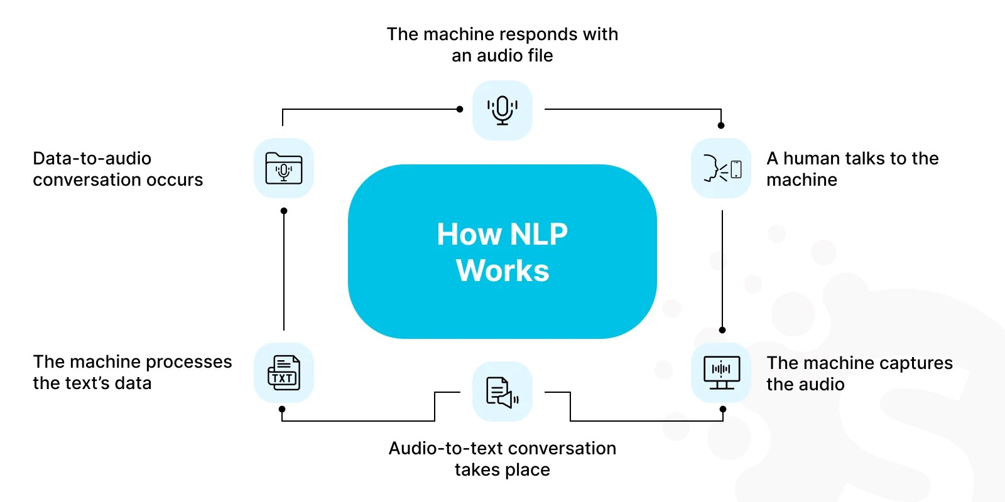

It is crucial for developing the applications that needs human-computer interaction. For instance, NLP allows machines to perform translation, sentimental analysis and question answering tasks.

**The role of machine learning in language models:**

Machine learning involves training computational models on large datasets to recognize patterns and make predictions or decisions. In the context of language models, ML algorithms are trained on large amounts of text data. Through this process, models learn the intricacies of language: grammar, syntax, and context.

They become more dynamic, context-aware, and efficient in language understanding and generation. ML models can forecast the likelihood of a word sequence, helping in auto-completion, code generation, and language translation.

**Understanding Deep Learning in the Context of NLP:**

A subset of machine learning, deep learning, has been instrumental in advancing NLP. It involves neural networks with multiple layers that *can learn and make smart decisions independently.*

In NLP, deep learning models, based on architectures like recurrent neural networks and transformers, can effectively process sequential data. They have become ideal for language generation, sentiment analysis, and syntactic parsing.

**Steps to Build a Large Language Model:**

Building a large language model involves a multi-faceted and intricate process. Each step of making a large language model is critical, from planning to implementation.

 Here's an overview of the key stages involved in this process:

LLMs are machine learning models that aim to predict language, after being trained on a massive amount of text data. Building a large language model is a complex process that involves two main phases: pre-training and alignment. This initial phase is crucial, and is generally structured around six steps:

**PHASE -1 – PRE-TRAINING:**

* **Step 1 – Data collection and preprocessing:**

 Gather a vast and varied dataset from the internet, including billions of text sources. This can include books, articles, websites, and more. Preprocess the data by tokenizing the text into smaller units (words or sub words), removing irrelevant content, and organizing it for efficient training.

* **Step 2 – Designing the transformer architecture**:

Select a suitable variant of the transformer architecture, like the generative pre-trained transformer (GPT) architecture. This architecture consists of multiple layers of self-attention mechanisms and feed-forward neural networks that enable the model to understand context and relationships between words.

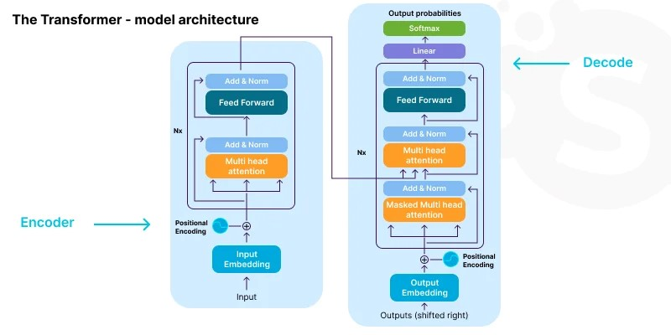

* **Step 3 – Model initialization:**

 Initialize the model with random weights, creating a blank slate for learning. These weights will be adjusted during the training process through backpropagation.

* **Step 4 – Pre-training objective**:

Define a pre-training objective, typically a language modelling task. The model learns to predict the next word in a sentence given the preceding words, fostering an understanding of syntax, grammar, and context.

* **Step 5 – Training**:

The training process is where the model learns from the data. Data scientists start feeding the prepared dataset into the model, initiating this process. The model’s parameters are updated iteratively to minimize the difference between predicted and actual next words.

* **Step 6: Model Size and Scaling**:

The size of a model is crucially important. Larger models can grasp more complex patterns, but they need more computing power. It's important to find the right balance between computational capacity and model size. Bigger models have more parameters, which means they can learn a wider variety of patterns. However, training them takes longer and requires more data.

**Phase 2 – Alignment:**

In the alignment phase, the model is adapted to specific tasks through fine-tuning on task specified data.

* **Step 1 – Task definition**:

Determine the target task you want the model to perform, such as text generation, translation, sentiment analysis, etc.

* **Step 2 – Task-specific data collection**:

Gather a dataset specifically tailored to your target task.

* **Step 3 – Fine-tuning objective:**

Design a task-specific objective, which guides the model’s learning during fine-tuning. For example, in sentiment analysis, the objective might be to correctly predict sentiment labels.

* **Step 4 – Fine-tuning**:

Continuous training of the model using the task-specific dataset while keeping the weights learned during pre-training frozen. This allows the model to retain its general language understanding while adapting to the task-specific data.

* **Step 5 – Evaluation and iteration**:

Evaluate the fine-tuned model’s performance on validation data. Fine-tuning might require several iterations of parameter adjustments to achieve optimal task performance.

* **Step 6 – Model deployment**:

Once you’re satisfied with the fine-tuned model’s performance, you can deploy it for your intended task, benefiting from both the model’s general language understanding and its task-specific adaptability.

**HOW DO YOU MODEL A LANGUAGE**

Language modelling involves the creation of statistical and deep learning models for predicting the likelihood of a tokens in a specified vocabulary.

They can be created by using either one of the following two tasks.

Auto Regression Task

Auto Encoding Task

**Huge Amounts of Data**

**Powerful Architecture**

Eg: BERT (Bidirectional Encoder Representations from Transformers)

It is a language model based on the transformer architecture. It does not use either of the two approaches (Auto Regressive/Auto Encoder). Instead, they used their own approach called Masked Language Modelling.

**Auto Regressive Language Model**

Auto Regressive models are a type of machine learning or statistical model that predicts the next value in the sequence based on the previous values in that sequence. These models assume that the future values in the sequence are dependant on the past values and use this dependency to make these predictions.

These are used to predict the future values across these number of cases like Financial Markets, Energy Consumptions, Natural Language Processing (NLP). The benefits of this model are simplicity, efficiency, interpretability, flexibility, diagnostics and model checking.

**Auto Encoding Language Model**

Auto encoding models work by creating short summaries (embeddings) of an input text. They do this by trying to fix or fill in the gaps in the jumbled version of the original text. They guess the missing words while looking at the nearby words for clues.

An example of auto encoding model is BERT. These models produce compact representations of input text and reconstruct the original input by predicting the missing words. They excel in various tasks like sentiment analysis, question answering and more.

Auto encoding is an unsupervised learning algorithm in which artificial neural network (ANN) is designed in a way to perform task of data encoding plus data decoding to reconstruct input.

Auto encoding models create a bidirectional representation of a whole sentence. They can be fine tuned for variety of tasks but their main application is sentence classification.

Auto encoding models are bidirectional. That means, they learn to generate sequences by considering both past and future contexts simultaneously.

**Conclusion**

From the provided information, we can understand the following:

1. Models are Vital: Models are crucial tools in understanding and processing language. They help computers make predictions and identify patterns in text.

2. Language Models Matter: Language models play a big role in Natural Language Processing (NLP). They help computers understand and generate human-like text by predicting words in context.

3. Big Models Are Popular: Large Language Models (LLMs) like GPT-2 and BERT are widely used and appreciated for their ability to handle various language tasks effectively.

4. Steps to Build Models: Building language models involves several steps, including collecting data, setting up the model, and fine-tuning it for specific tasks. Each step is important for creating accurate models.

5. Autoencoding for Text: Autoencoding language models, such as BERT, are focused on summarizing text and filling in missing words. They're handy for tasks like analysing sentiments or answering questions.

6. Understanding is Key: Understanding these models helps us improve how computers understand and generate human language, which is crucial for many applications in technology and communication.